**S-100 – Part 2b**

Portrayal Register

Summary of Substantive Changes in Edition 5.2.0

|  |  |
| --- | --- |
| Change Summary | Clauses Effected |
| **Part 2b – Portrayal Register** | |
|  |  |
|  |  |

Contents

2b-1 Scope 1

2b-1.1 Conformance 1

2b-2 Normative references 1

2b-3 General concepts 2

2b-3.1 Register 2

2b-3.2 Portrayal Register 2

2b-3.3 Portrayal catalogue 2

2b-4 IHO Portrayal Register 2

2b-4.1 Types of registered items 2

2b-4.2 Data model of a Portrayal Register 3

2b-4.2.1 UML Model 3

2b-4.2.2 S100_PR_Register 5

2b-4.2.3 S100_PR_RegisterDomain 5

2b-4.2.4 S100_PR_User 5

2b-4.2.5 S100_PR_RegisterManager 6

2b-4.2.6 S100_PR_RegisterOrganization 6

2b-4.2.7 S100_PR_RegisterPermissions 6

2b-4.2.8 S100_PR_ ManagementInfo 7

2b-4.2.9 S100_PR_ Attachment 7

2b-4.2.10 S100_PR_ RegisterItem 7

2b-4.2.11 S100_PR_ VisualItem 8

2b-4.2.12 S100_PR_ Symbol 8

2b-4.2.13 S100_PR_ LineStyle 8

2b-4.2.14 S100_PR_ AreaFill 9

2b-4.2.15 S100_PR_ Pixmap 9

2b-4.2.16 S100_PR_ ItemSchema 9

2b-4.2.17 S100_PR_ColourToken 10

2b-4.2.18 S100_PR_ColourPalette 10

2b-4.2.19 S100_PR_PaletteItem 11

2b-4.2.20 S100_PR_DisplayMode 11

2b-4.2.21 S100_PR_ViewingGroupLayer 11

2b-4.2.22 S100_PR_ViewingGroup 11

2b-4.2.23 S100_PR_DisplayPlane 12

2b-4.2.24 S100_PR_Font 12

2b-4.2.25 S100_PR_DrawingPriority 12

2b-4.2.26 S100_PR_ContextParameter 12

2b-4.2.27 S100_PR_ColourValue 13

2b-4.2.28 S100_PR_SRGBValue 13

2b-4.2.29 S100_PR_CIEValue 13

2b-4.2.30 S100_PR_Alert 14

2b-4.2.31 S100_PR_AlertInfo 14

2b-4.2.32 S100_PR_AlertPriority 14

2b-4.2.33 S100_PR_AlertMessage 15

2b-4.2.34 S100_PR_AlertHighlight 15

2b-4.2.35 S100_PR_NationalLanguageString 16

2b-4.2.36 S100_PR_FileType 16

2b-4.2.37 S100_PR_FontType 16

2b-4.2.38 S100_PR_ImageType 16

2b-4.2.39 S100_PR_AlertPriorityType 17

2b-4.2.40 S100_PR_ParameterType 17

2b-4.2.41 S100_PR_HighlightStyle 17

Page intentionally left blank

# Scope

The IHO Geospatial Information (GI) Registry contains a number of Registers, one of which will be for portrayal. The Portrayal Register registers the components used to build Portrayal Catalogues. When provided with a Feature Catalogue and compliant data, a Portrayal Catalogue built from registered components transforms features and attributes into a portrayal.

The portrayal of data is independent of the data but closely related to the data. That is, the attributes within the data set drive the portrayal process, but there may be many different portrayals for the same data.

The use of a Register to store portrayal components improves the IHO’s ability to manage and extend the portrayal of products based on S-100. This Register supports wider use of registered items by making them publicly available and increasing their visibility to Portrayal Catalogue developers. This Part describes the content of the Portrayal Register.

## Conformance

This profile conforms to conformance class 2 of ISO 19106:2004.

# Normative references

The following referenced documents are required for the application of this document. For dated references, only the edition cited applies. For undated references, the latest edition of the referenced document (including amendments) applies.

ISO 19135:2005, *Geographic Information – Procedures for registration of items of geographic information*

ISO 19126:2009, *Geographic Information – Feature concept dictionaries and registers*

ISO 19117:2012, *Geographic Information – Portrayal*

# General concepts

## Register

As described in Part 2, a Register is simply a managed list. It is easier to maintain than a fixed document, because new items can be added as needed to the Register, and existing items in the Register can be clarified, superseded or retired. Each Register item has one or more dates associated with it that indicate when changes in its status occurred. This means that a Product Specification, defined at a given date, may reference an item in the Register at that specific point in time.

## Portrayal Register

The Portrayal Register specifies the independent sets of components used to build Portrayal Catalogues such as colours, symbols, and fonts. The Register also specifies supporting items such as context parameters, viewing groups, display planes and the components used within an optional Alerts Catalogue.

The Portrayal Register may be subdivided into different Domains; and may be used to develop a Portrayal Catalogue. Unlike a Portrayal Catalogue, the Portrayal Register does not define the portrayal rules or bind the portrayal or alerts/indications to a feature.

Such Registers of portrayal information may serve as sources of reference for similar Registers established by other geographic information communities as part of a system of cross-referencing.

## Portrayal catalogue

The Portrayal Catalogue contains portrayal rules that map the features to symbology; and optionally to alerts/indications. It also contains symbol definitions, colour definitions, portrayal parameters and portrayal management concepts. Portrayal Catalogues are described in detail in S-100 Part 9.

# IHO Portrayal Register

## Types of registered items

The following are types of items that may be registered:

1. Pixmap
2. Colour Value
3. Colour Token
4. Colour Palette
5. Symbol
6. Line Style
7. Area Fill
8. Font
9. Viewing Group
10. Viewing Group Layer
11. Display Mode
12. Display Plane
13. Context Parameter
14. Symbol Schema
15. Line Style Schema
16. Area Fill Schema
17. Pixmap Schema
18. Colour Profile Schema
19. Drawing Priority
20. Alert
21. Alert Message
22. Alert Highlight

## Data model of a Portrayal Register

### UML Model

Figures 2b-1 and 2b-2 show the register management and information models respectively of the hydrographic Portrayal Register:

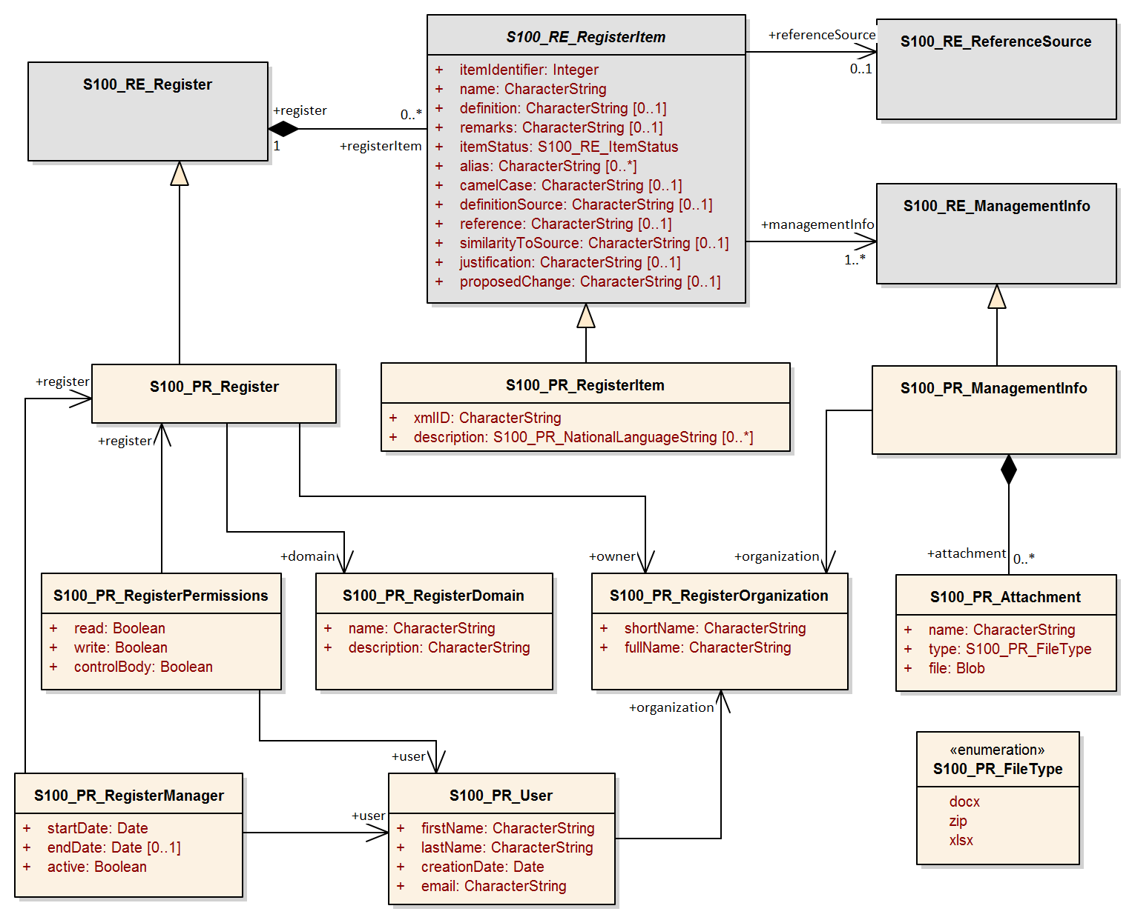

Figure 2b-1 – Portrayal Register management model

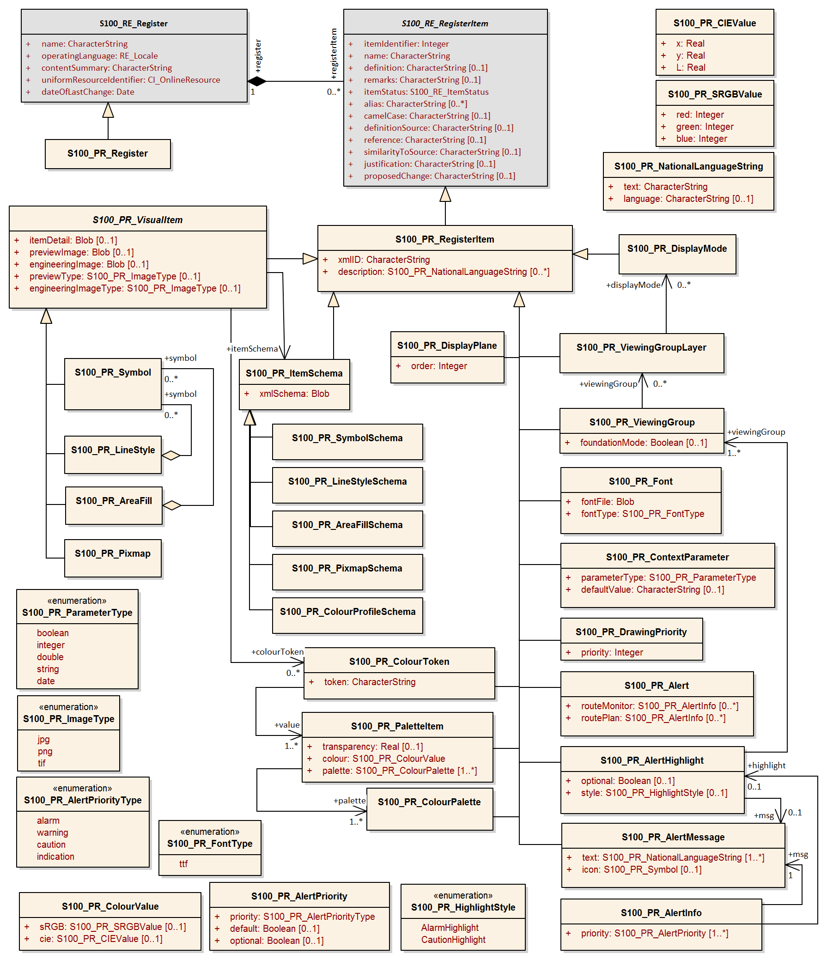

Figure 2b-2 – Portrayal Register information model

### S100_PR_Register

This class S100_PR_Register is a specialization of the class S100_RE_Register. It is extended with an ‘owner’ and ‘domain’. An organization may have a dedicated Register and a Register is intended for a specific Domain.

|  |  |  |  |  |  |
| --- | --- | --- | --- | --- | --- |
| Role Name | Name | Description | Mult | Data Type | Remarks |
| Class | S100_PR_Register | Portrayal Register extension to S100_RE_Register | - | S100_RE_Register | Inherits all characteristics of S100_RE_RegisterItem and extended with domain and owner |
| Association | owner | The organization responsible for managing the contents of the Register | 1 | S100_PR_RegisterOrganization |  |
| Association | domain | The domain for which the Register is primarily intended | 1 | S100_PR_RegisterDomain |  |

### S100_PR_RegisterDomain

This class indicates the Domain for which a Register is intended.

|  |  |  |  |  |  |
| --- | --- | --- | --- | --- | --- |
| Role Name | Name | Description | Mult | Data Type | Remarks |
| Class | S100_PR_RegisterDomain | Definition of a Domain | - | - |  |
| Attribute | name | Name of Domain | 1 | CharacterString |  |
| Attribute | description | Description of Domain | 1 | CharacterString |  |

### S100_PR_User

This class represents a user of the Register.

|  |  |  |  |  |  |
| --- | --- | --- | --- | --- | --- |
| Role Name | Name | Description | Mult | Data Type | Remarks |
| Class | S100_PR_RegisterUser | Identification of a Register user | - | - |  |
| Attribute | firstName | First name of user | 1 | CharacterString |  |
| Attribute | lastName | Last name of user | 1 | CharacterString |  |
| Attribute | creationDate | Date user was entered | 1 | Date |  |
| Attribute | email | Email of user | 1 | CharacterString |  |
| Association | organization | Reference to organization | 1 | S100_PR_RegisterOrganization |  |

### S100_PR_RegisterManager

This class identifies a Register Manager along with current status and time period.

|  |  |  |  |  |  |
| --- | --- | --- | --- | --- | --- |
| Role Name | Name | Description | Mult | Data Type | Remarks |
| Class | S100_PR_RegisterManager | Indicates the manager of a Register | - | - |  |
| Attribute | startDate | The start date of the manager | 1 | Date |  |
| Attribute | endDate | The date on which the manager duties end | 0..1 | Date |  |
| Attribute | active | Flag if manager is currently active | 1 | Boolean |  |
| Association | register | The Register that the manager manages | 1 | S100_PR_Register |  |
| Association | user | The user that is the manager | 1 | S100_PR_User |  |

### S100_PR_RegisterOrganization

This class represents a Register Organization.

|  |  |  |  |  |  |
| --- | --- | --- | --- | --- | --- |
| Role Name | Name | Description | Mult | Data Type | Remarks |
| Class | S100_PR_RegisterOrganization | Definition of a Register Organization | - | - |  |
| Attribute | shortName | Abbreviated or simple form name | 1 | CharacterString |  |
| Attribute | fullName | Full name of organization | 1 | CharacterString |  |

### S100_PR_RegisterPermissions

A class used to assign permissions to a Register user.

|  |  |  |  |  |  |
| --- | --- | --- | --- | --- | --- |
| Role Name | Name | Description | Mult | Data Type | Remarks |
| Class | S100_PR_RegisterPermissions | Register user permissions | - | - |  |
| Attribute | read | Permission to read Register entries | 1 | Boolean |  |
| Attribute | write | Permission to write Register entries | 1 | Boolean |  |
| Attribute | controlBody | User is Control Body | 1 | Boolean | Part 2 Management of Registers |
| Association | register | The Register that the manager manages | 1 | S100_PR_Register |  |
| Association | user | The user that is the manager | 1 | S100_PR_User |  |

### S100_PR_ ManagementInfo

This class is a portrayal extension of the S100_RE_ManagementInfo class with a reference to an Organization object and possible attachments.

|  |  |  |  |  |  |
| --- | --- | --- | --- | --- | --- |
| Role Name | Name | Description | Mult | Data Type | Remarks |
| Class | S100_PR_ManagementInfo | Extension of S100_RE_ManagementInfo | - | S100_RE_ManagementInfo |  |
| Association | organization | Organization submitting Register entries | 1 | S100_PR_RegisterOrganization |  |
| Association | attachment | Attached file or files | 0..* | S100_PR_Attachment |  |

### S100_PR_ Attachment

This class handles attachments.

|  |  |  |  |  |  |
| --- | --- | --- | --- | --- | --- |
| Role Name | Name | Description | Mult | Data Type | Remarks |
| Class | S100_PR_ Attachment | Holds an attached file | - | - |  |
| Attribute | name | Name of attachment | 1 | CharacterString |  |
| Attribute | type | Type of attachment | 1 | S100_PR_FileType |  |
| Attribute | file | The attachment | 1 | Blob |  |

### S100_PR_ RegisterItem

The class S100_PR_RegisterItem is a specialization of the class S100_RE_RegisterItem which carries a valid XML identifier to be used in a Portrayal Catalogue.

|  |  |  |  |  |  |
| --- | --- | --- | --- | --- | --- |
| Role Name | Name | Description | Mult | Data Type | Remarks |
| Class | S100_PR_RegisterItem | Extension of S100_RE_RegisterItem | - | S100_RE_RegisterItem |  |
| Attribute | xmlID | Valid XML identifier string | 1 | CharacterString |  |
| Attribute | description | Description in a national language | 0..* | S100_PR_NationalLanguageString | Provides S100_RE_RegisterItem definition attribute in alternate languages, supporting population of Portrayal Catalogue language-independent descriptions |

### S100_PR_ VisualItem

An abstract specialization of S100_PR_RegisterItem to represent ‘symbol’, ‘lineStyle’, ‘areaFill’ or ‘pixmap’. The visual items each have an XML identifier string and XML document defining the item details as well as a preview image and an engineering image with dimensions.

|  |  |  |  |  |  |
| --- | --- | --- | --- | --- | --- |
| Role Name | Name | Description | Mult | Data Type | Remarks |
| Class | S100_PR_VisualItem | Abstract class representing a graphic element such as a symbol or linestyle | - | S100_PR_ RegisterItem |  |
| Attribute | itemDetail | The XML file of the item | 0..1 | Blob |  |
| Attribute | previewImage | A preview image of the item | 0..1 | Blob |  |
| Attribute | engineeringImage | The engineering image with measurements | 0..1 | Blob |  |
| Attribute | previewType | The file type of the preview image | 0..1 | S100_PR_ImageType | Required if previewImage is populated |
| Attribute | engineeringImageType | The file type of the engineering image | 0..1 | S100_PR_ImageType | Required if engineeringImage is populated |
| Association | itemSchema | The XML schema to validate the item | 1 | S100_PR_ItemSchema |  |
| Association | colourToken | The colour tokens used by the visual item | 0..* | S100_PR_ColourToken | Needed to identify dependencies when assembling a Portrayal Catalogue |

### S100_PR_ Symbol

The class S100_PR_Symbol is a specialization of the class S100_PR_VisualItem used to register a symbol according to Part 9 Portrayal.

|  |  |  |  |  |  |
| --- | --- | --- | --- | --- | --- |
| Role Name | Name | Description | Mult | Data Type | Remarks |
| Class | S100_PR_Symbol | Symbol visual item | - | S100_PR_VisualItem |  |

### S100_PR_ LineStyle

The class S100_PR_LineStyle is a specialization of the class S100_PR_VisualItem used to register a linestyle according to Part 9 Portrayal.

|  |  |  |  |  |  |
| --- | --- | --- | --- | --- | --- |
| Role Name | Name | Description | Mult | Data Type | Remarks |
| Class | S100_PR_LineStyle | Line style visual item | - | S100_PR_VisualItem |  |
| Association | symbol | Symbols used by the line style | 0..* | S100_PR_ Symbol | Used to identify dependencies |

### S100_PR_ AreaFill

The class S100_PR_AreaFill is a specialization of the class S100_PR_VisualItem used to register an area fill according to Part 9 Portrayal.

|  |  |  |  |  |  |
| --- | --- | --- | --- | --- | --- |
| Role Name | Name | Description | Mult | Data Type | Remarks |
| Class | S100_PR_AreaFill | Area fill visual item | - | S100_PR_VisualItem |  |
| Association | symbol | Symbols used by the area fill | 0..* | S100_PR_ Symbol | Used to identify dependencies |

### S100_PR_ Pixmap

The class S100_PR_Pixmap is a specialization of the class S100_PR_VisualItem used to register a pixmap according to Part 9 Portrayal.

|  |  |  |  |  |  |
| --- | --- | --- | --- | --- | --- |
| Role Name | Name | Description | Mult | Data Type | Remarks |
| Class | S100_PR_Pixmap | Pixmap visual item | - | S100_PR_VisualItem |  |

### S100_PR_ ItemSchema

The class S100_PR_ItemSchema is a specialization of the class S100_PR_RegisterItem used to register a portrayal item schema according to Part 9 Portrayal.

|  |  |  |  |  |  |
| --- | --- | --- | --- | --- | --- |
| Role Name | Name | Description | Mult | Data Type | Remarks |
| Class | S100_PR_ItemSchema | Schema of an XML portrayal item | - | S100_PR_RegisterItem |  |
| Attribute | xmlSchema | The XML schema stored as a Blob | 1 | Blob | Schema from Part 9 Portrayal |

#### S100_PR_ SymbolSchema

The class is a specialization of S100_PR_ItemSchema and is used to register the Part 9 Portrayal symbol schema.

|  |  |  |  |  |  |
| --- | --- | --- | --- | --- | --- |
| Role Name | Name | Description | Mult | Data Type | Remarks |
| Class | S100_PR_SymbolSchema | Symbol schema | - | S100_PR_ItemSchema |  |

#### S100_PR_ LineStyleSchema

The class is a specialization of S100_PR_ItemSchema and is used to register the Part 9 Portrayal line style schema.

|  |  |  |  |  |  |
| --- | --- | --- | --- | --- | --- |
| Role Name | Name | Description | Mult | Data Type | Remarks |
| Class | S100_PR_LineStyleSchema | Line style schema | - | S100_PR_ItemSchema |  |

#### S100_PR_ AreaFillSchema

The class is a specialization of S100_PR_ItemSchema and is used to register the Part 9 Portrayal area fill schema.

|  |  |  |  |  |  |
| --- | --- | --- | --- | --- | --- |
| Role Name | Name | Description | Mult | Data Type | Remarks |
| Class | S100_PR_AreaFillSchema | Area fill schema | - | S100_PR_ItemSchema |  |

#### S100_PR_ PixmapSchema

The class is a specialization of S100_PR_ItemSchema and is used to register the Part 9 Portrayal pixmap schema.

|  |  |  |  |  |  |
| --- | --- | --- | --- | --- | --- |
| Role Name | Name | Description | Mult | Data Type | Remarks |
| Class | S100_PR_PixmapSchema | Pixmap schema | - | S100_PR_ItemSchema |  |

#### S100_PR_ ColourProfileSchema

The class is a specialization of S100_PR_ItemSchema and is used to register the Part 9 colour profile schema.

|  |  |  |  |  |  |
| --- | --- | --- | --- | --- | --- |
| Role Name | Name | Description | Mult | Data Type | Remarks |
| Class | S100_PR_ColourProfileSchema | Colour profile schema | - | S100_PR_ItemSchema |  |

### S100_PR_ColourToken

The class S100_PR_ColourToken is a specialization of the class S100_PR_RegisterItem. A color token defines a single reference for multiple color values, each of which is associated with a single colour palette.

|  |  |  |  |  |  |
| --- | --- | --- | --- | --- | --- |
| Role Name | Name | Description | Mult | Data Type | Remarks |
| Class | S100_PR_ColourToken | Definition of a colour token | - | S100_PR_RegisterItem |  |
| Attribute | token | Identifier of the colour value(s) | 1 | CharacterString |  |
| Association | value | The colour(s) associated with this token | 1..* | S100_PR_PaletteItem | Used to identify dependencies  Multiplicity if intended for use by ECDIS is 3..* |

### S100_PR_ColourPalette

The class S100_PR_ColourPalette is a specialization of the class S100_PR_RegisterItem.

|  |  |  |  |  |  |
| --- | --- | --- | --- | --- | --- |
| Role Name | Name | Description | Mult | Data Type | Remarks |
| Class | S100_PR_ColourPalette | Definition of a colour palette | - | S100_PR_RegisterItem |  |

### S100_PR_PaletteItem

The class S100_PR_PaletteItem is a specialization of the class S100_PR_RegisterItem. It provides a colour value for colour tokens within a colour palette.

|  |  |  |  |  |  |
| --- | --- | --- | --- | --- | --- |
| Role Name | Name | Description | Mult | Data Type | Remarks |
| Class | S100_PR_PaletteItem | Definition of a colour palette entry | - | S100_PR_RegisterItem |  |
| Attribute | transparency | Transparency | 0..1 | Real | Range is [0, 1], default is 0 (opaque) |
| Attribute | colour | The colour value | 1 | S100_PR_ColourValue |  |
| Association | palette | The palette(s) associated with this item | 1..* | S100_PR_ColourPalette | Used to identify dependencies |

### S100_PR_DisplayMode

This is a specialization of the class S100_PR_RegisterItem used to register a Display Mode according to Part 9 Portrayal.

|  |  |  |  |  |  |
| --- | --- | --- | --- | --- | --- |
| Role Name | Name | Description | Mult | Data Type | Remarks |
| Class | S100_PR_DisplayMode | Used to register a Display Mode | - | S100_PR_RegisterItem | See Part 9 Portrayal |

### S100_PR_ViewingGroupLayer

This is a specialization of the class S100_PR_RegisterItem used to register a Viewing Group Layer according to Part 9 Portrayal.

|  |  |  |  |  |  |
| --- | --- | --- | --- | --- | --- |
| Role Name | Name | Description | Mult | Data Type | Remarks |
| Class | S100_PR_ViewingGroupLayer | Used to register a Viewing Group Layer | - | S100_PR_RegisterItem | See Part 9 Portrayal |
| Association | displayMode | A display mode which may include this layer | 0..* | S100_PR_DisplayMode | Used to identify dependencies |

### S100_PR_ViewingGroup

This is a specialization of the class S100_PR_RegisterItem used to register a Viewing Group according to Part 9 Portrayal.

|  |  |  |  |  |  |
| --- | --- | --- | --- | --- | --- |
| Role Name | Name | Description | Mult | Data Type | Remarks |
| Class | S100_PR_ViewingGroup | Used to register a Viewing Group | - | S100_PR_RegisterItem | See Part 9 Portrayal |
| Attribute | foundationMode | Indicates the viewing group should always be on. | 0..1 | Boolean | Default is false |
| Association | viewingGroupLayer | A viewing group layer which may include this viewing group | 0..* | S100_PR_ViewingGroupLayer | Used to identify dependencies |

### S100_PR_DisplayPlane

This is a specialization of the class S100_PR_RegisterItem.

|  |  |  |  |  |  |
| --- | --- | --- | --- | --- | --- |
| Role Name | Name | Description | Mult | Data Type | Remarks |
| Class | S100_PR_DisplayPlane | The specific content for a display plane definition as a register item of type ‘displayPlane’ | - | S100_PR_RegisterItem | See Part 9 Portrayal |
| Attribute | order | Used to sort the drawing order of display planes | 1 | Integer |  |

### S100_PR_Font

This is a specialization of S100_PR_RegisterItem. Used to register a font file for use in a Portrayal Catalogue.

|  |  |  |  |  |  |
| --- | --- | --- | --- | --- | --- |
| Role Name | Name | Description | Mult | Data Type | Remarks |
| Class | S100_PR_Font | The specific content for a font file definition as a register item of type ‘font’ | - | S100_PR_RegisterItem | See Part 9 Portrayal |
| Attribute | fontFile | A font file for inclusion in a portrayal catalogue | 1 | Blob |  |
| Attribute | fontType | The type of font file | 1 | S100_PR_FontType | Initially restricted to True Type Font |

### S100_PR_DrawingPriority

S100_PR_DrawingPriority is a specialization of S100_PR_RegisterItem.

|  |  |  |  |  |  |
| --- | --- | --- | --- | --- | --- |
| Role Name | Name | Description | Mult | Data Type | Remarks |
| Class | S100_PR_DrawingPriority | Used to register drawing priorities to be used in a Portrayal Catalogue | - | S100_PR_ RegisterItem | See Part 9 Portrayal |
| Attribute | priority | Used to sort drawing instructions within a display plane | 1 | Integer |  |

### S100_PR_ContextParameter

S100_PR_ContextParameter is a specialization of S100_PR_RegisterItem.

|  |  |  |  |  |  |
| --- | --- | --- | --- | --- | --- |
| Role Name | Name | Description | Mult. | Data Type | Remarks |
| Class | S100_PR_ContextParameter | The specific content for a context parameter as a register item of type ‘contextParameter’ | - | S100_PR_ RegisterItem | See Part 9 Portrayal |
| Attribute | parameterType | Data type of context parameter | 1 | S100_PR_ParameterType |  |
| Attribute | defaultValue | Default or initial value | 0..1 | CharacterString |  |

### S100_PR_ColourValue

Identifies a colour value in one or more colour spaces.

|  |  |  |  |  |  |
| --- | --- | --- | --- | --- | --- |
| Role Name | Name | Description | Mult. | Data Type | Remarks |
| Class | S100_PR_ColourValue | Describes a colour value in one or more colour spaces | - | - | At least one colour value must be present |
| Attribute | sRGB | The colour value in the sRGB colour space | 0..1 | S100_PR_SRGBValue |  |
| Attribute | cie | The colour value in the CIE colour space | 0..1 | S100_PR_CIEValue |  |

### S100_PR_SRGBValue

Identifies a colour value in the sRGB colour space.

|  |  |  |  |  |  |
| --- | --- | --- | --- | --- | --- |
| Role Name | Name | Description | Mult. | Data Type | Remarks |
| Class | S100_PR_SRGBValue | A colour value in the sRGB colour space | - | - |  |
| Attribute | red | Amount of red | 1 | Integer | Range is [0,255] |
| Attribute | green | Amount of green | 1 | Integer | Range is [0,255] |
| Attribute | blue | Amount of blue | 1 | Integer | Range is [0,255] |

### S100_PR_CIEValue

Identifies a colour value in the CIE colour space.

|  |  |  |  |  |  |
| --- | --- | --- | --- | --- | --- |
| Role Name | Name | Description | Mult. | Data Type | Remarks |
| Class | S100_PR_CIEValue | A colour value in the CIE colour space | - | - |  |
| Attribute | x | x component of the chromaticity | 1 | Real | Range [0,1] |
| Attribute | y | y component of the chromaticity | 1 | Real | Range [0,1] |
| Attribute | L | Luminance in cd/m2 | 1 | Real |  |

### S100_PR_Alert

S100_PR_Alert is a specialization of S100_PR_RegisterItem. An alert is associated with features by Portrayal Catalogue rules.

|  |  |  |  |  |  |
| --- | --- | --- | --- | --- | --- |
| Role Name | Name | Description | Mult. | Data Type | Remarks |
| Class | S100_PR_Alert | Provides a priority, message, and the viewing groups associated with a graphical highlight. | - | S100_PR_RegisterItem | One of routeMonitor or routePlan must be present |
| Attribute | routeMonitor | Describes the attributes of the alert during route monitoring | 0..* | S100_PR_AlertInfo |  |
| Attribute | routePlan | Describes the attributes of the alert during route planning | 0..* | S100_PR_AlertInfo |  |

### S100_PR_AlertInfo

|  |  |  |  |  |  |
| --- | --- | --- | --- | --- | --- |
| Role Name | Name | Description | Mult. | Data Type | Remarks |
| Class | S100_PR_AlertInfo | The attributes of an alert | - | - |  |
| Attribute | priority | The priority of the alert | 1..* | S100_PR_AlertPriority | Multiplicity supports user selection of priority |
| Association | msg | A message to display while the alert is active | 1 | S100_PR_AlertMessage |  |
| Association | highlight | Supports toggling display of the graphical highlight | 0..1 | S100_PR_AlertHighlight |  |

### S100_PR_AlertPriority

|  |  |  |  |  |  |
| --- | --- | --- | --- | --- | --- |
| Role Name | Name | Description | Mult. | Data Type | Remarks |
| Class | S100_PR_AlertPriority | The priority of an alert | - | - |  |
| Attribute | priority | The priority value | 1 | S100_PR_AlertPriorityType |  |
| Attribute | default | Indicates this priority is the default | 0..1 | Boolean | Default is false |
| Attribute | optional | Indicates exposing this priority to the user is optional | 0..1 | Boolean | Default is false |

### S100_PR_AlertMessage

S100_PR_AlertMessage is a specialization of S100_PR_RegisterItem. Messages are displayed while any associated alert is active.

|  |  |  |  |  |  |
| --- | --- | --- | --- | --- | --- |
| Role Name | Name | Description | Mult. | Data Type | Remarks |
| Class | S100_PR_AlertMessage | A message associated with one or more alerts | - | S100_PR_RegisterItem |  |
| Attribute | text | Message in one or more languages | 1..* | S100_PR_NationalLanguageString | Message in English must be provided |
| Association | icon | A symbol to display with or instead of the text. | 0..1 | S100_PR_Symbol |  |

### S100_PR_AlertHighlight

S100_PR_AlertHighlight is a specialization of S100_PR_RegisterItem. Highlights associate viewing groups with alert information, which allows users to disable graphical highlighting of one or more active S100_PR_Alerts.

|  |  |  |  |  |  |
| --- | --- | --- | --- | --- | --- |
| Role Name | Name | Description | Mult. | Data Type | Remarks |
| Class | S100_PR_AlertHighlight | Associates display parameters with alerts | - | S100_PR_RegisterItem |  |
| Attribute | style | Overrides the style of graphical highlight shown in the chart area | 0..1 | S100_PR_HighlightStyle | When empty, style is inferred from the alert priority   * Alarm: AlarmHighlight * Others: CautionHighlight |
| Attribute | optional | Indicates whether allowing the highlight to be turned off is optional | 0..1 | Boolean | Default is false |
| Association | viewingGroup | The viewing group(s) associated with an alert highlight (Portrayal Catalogue rules generate the drawing instructions which implement the highlight) | 1..* | S100_PR_ViewingGroup | Multiple viewing groups are present to allow highlighting of alerts triggered by specific feature types to be disabled independently  For example, ProhibitedAreaHighlight supports disabling highlighting of Seaplane Landing Areas while other prohibited areas continue to be highlighted  When multiple viewing groups are provided, consideration should be given to providing a viewing group layer to toggle all the viewing groups at once |
| Association | msg | A message to display while any of the viewing groups are disabled | 0..1 | S100_PR_AlertMessage |  |

### S100_PR_NationalLanguageString

|  |  |  |  |  |  |
| --- | --- | --- | --- | --- | --- |
| Role Name | Name | Description | Mult. | Data Type | Remarks |
| Class | S100_PR_NationalLanguageString | Text specific to a national language | - | - |  |
| Attribute | text | A string in a national language | 1 | CharacterString |  |
| Attribute | language | ISO 639-2/T 3-letter language code | 0..1 | CharacterString | Default is “eng“ |

### S100_PR_FileType

|  |  |  |  |  |
| --- | --- | --- | --- | --- |
| Item | Name | Description | Code | Remarks |
| Enumeration | S100_PR_FileType | The type and format of a file. | - |  |
| Value | docx | Office Open XML Document | - | Zip and XML-based file format for documents. Not to be confused with OpenOffice format or generic XML |
| Value | zip | Zip archive format | - |  |
| Value | xlsx | Office Open XML Workbook | - | Zip and XML-based file format for spreadsheets. Not to be confused with OpenOffice format or generic XML |

### S100_PR_FontType

|  |  |  |  |  |
| --- | --- | --- | --- | --- |
| Item | Name | Description | Code | Remarks |
| Enumeration | S100_PR_FontType | A font specification | - |  |
| Value | ttf | TrueType font | - |  |

### S100_PR_ImageType

|  |  |  |  |  |
| --- | --- | --- | --- | --- |
| Item | Name | Description | Code | Remarks |
| Enumeration | S100_PR_ImageType | An image specification | - |  |
| Value | jpg | JPEG 2000 image coding system | - |  |
| Value | png | Portable Network Graphics format | - |  |
| Value | tif | Tagged Image File Format | - |  |

### S100_PR_AlertPriorityType

|  |  |  |  |  |
| --- | --- | --- | --- | --- |
| Item | Name | Description | Code | Remarks |
| Enumeration | S100_PR_AlertPriorityType | Defines the possible priorities for an alert. | - |  |
| Value | alarm | Indicates conditions requiring immediate attention and action by the bridge team | - | From MSC.252(83) 19.1.2 |
| Value | warning | Indicates changed conditions and should be presented for precautionary reasons which are not immediately hazardous but which may become so, if no action is taken | - | From MSC.252(83) 19.1.3 |
| Value | caution | Indicates a condition which does not warrant an alarm or warning condition, but still requires attention and out of the ordinary consideration of the situation or of given information | - | From MSC.252(83) 19.1.4 |
| Value | indication | Display of regular information and conditions | - | From MSC.252(83) appendix 1 |

### S100_PR_ParameterType

The definition and members of enumeration S100_PR_ParameterType are the same as ParameterType in Part 9, clause 9-13.3.30.

### S100_PR_HighlightStyle

|  |  |  |  |  |
| --- | --- | --- | --- | --- |
| Item | Name | Description | Code | Remarks |
| Enumeration | S100_PR_HighlightStyle | Defines the possible graphical highlight styles for an alert | - |  |
| Value | AlarmHighlight | Red highlight | - | IEC 62288:2014 Table A.3 Navigation symbols, entry 3.5 b |
| Value | CautionHighlight | Yellow highlight | - | IEC 62288:2014 Table A.3 Navigation symbols, entry 3.5 c |

Page intentionally left blank